Project Design Phase-II

Technology Architecture

|  |  |
| --- | --- |
| Date | 03 October 2022 |
| Team ID | PNT2022TMIDxxxxxx |
| Project Name | Emerging methods for early detection of forest fires |
| Maximum Marks | 4 Marks |

Technical Architecture:

The Deliverable shall include the architectural diagram as below and the information as per the table1 & table 2

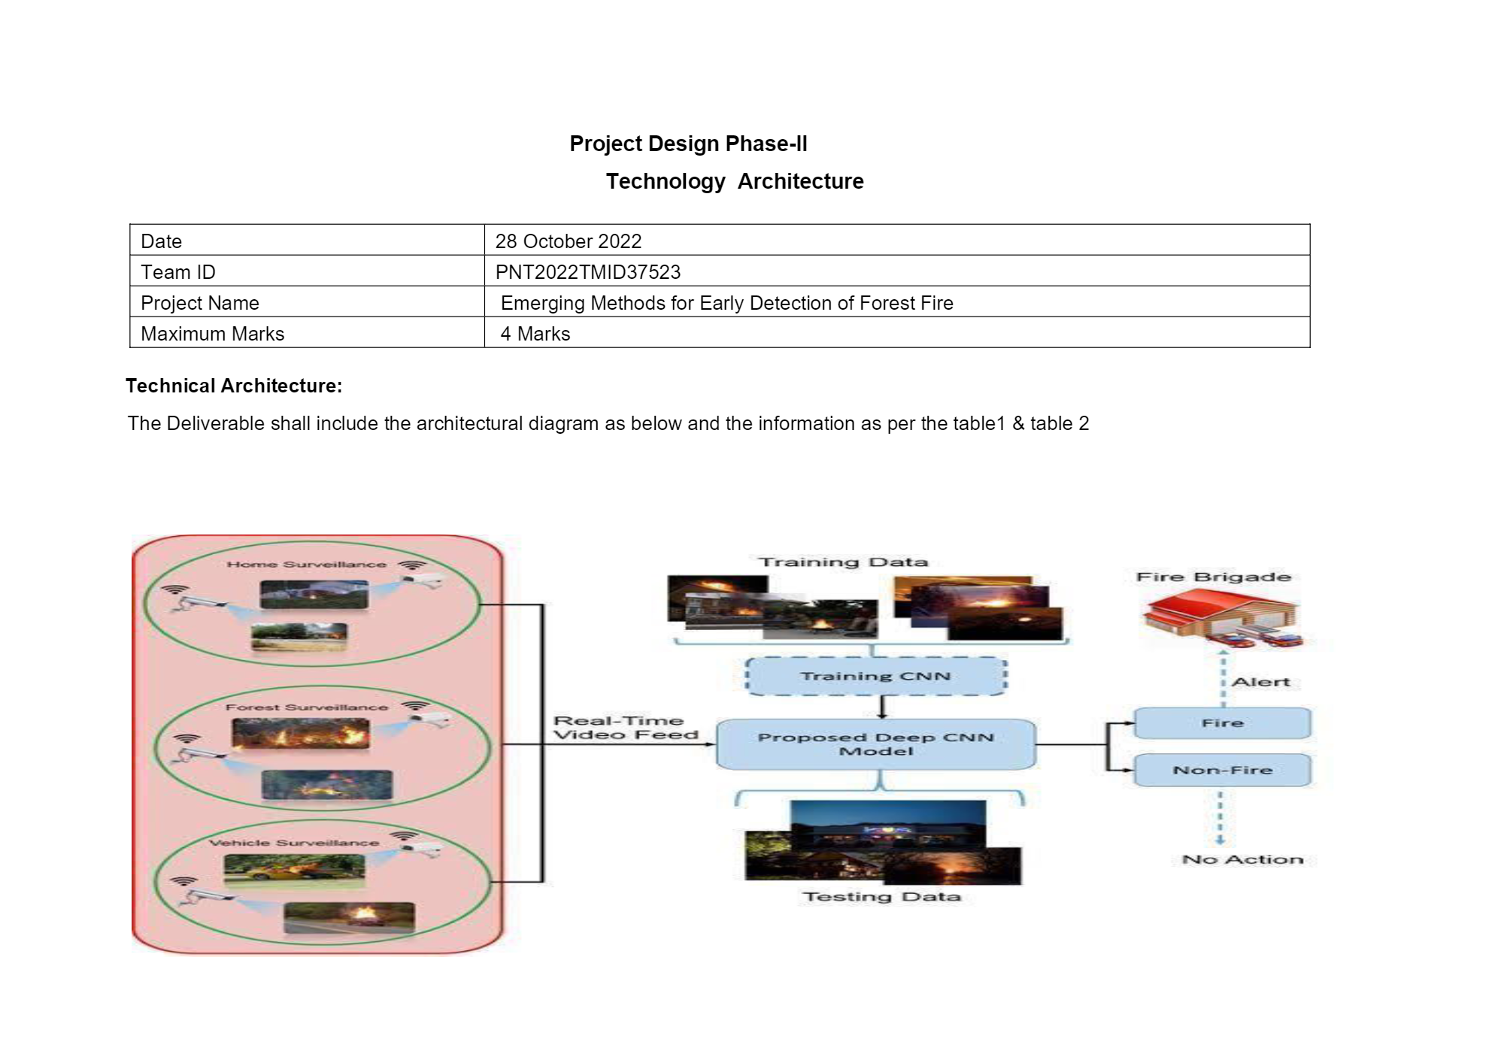

Table-1 : Components & Technologies:

|  |  |  |  |
| --- | --- | --- | --- |
| **S.No** | **Component** | **Description** | **Technology** |
| 1. | User Interface (Camera) | How user interacts or see the video feed into the computer | High quality cameras |
| 2. | Camera and Drones | Watching the forest; surveillance provider (24*7) all the time | Pan tilt zoom cameras can be used |
| 3. | Fire System | Identifying smoke by clustering motions with a time input to reduce the number of false alarms. | URA Fire System |
| 4. | Communication | To send the videos from camera to the system | Network Tower |
| 5. | Cloud Database | Database Service on Cloud | IBM Cloud |
| 6. | Application to get the video feed | It gets the image and helps the CNN so check whether fire is present | IBM Watson assistant |
| 7. | Sensor | Rotates the camera 360 degree every 4 to 6 minutes in a day  OSS at the tower has a wireless connection to the user computer | Optical Sensor can be used |
| 8. | Image recognizer | It learns and extract complex image features effectively | CNN algorithms can be used |
| 9. | Detector | It will send an alert sound if the CNN detects the fire | Sound Alarm |
| 10. | CNN | Gets the image, process it and finds whether fire occurs or not | Four algorithms are used Faster-RCNN, R-FCN, SDD , YOLO V3 |

Table-2: Application Characteristics:

|  |  |  |  |
| --- | --- | --- | --- |
| **S.No** | **Characteristics** | **Description** | **Technology** |
| 1. | Open CV | Open – Source Library for image processing | Python Programming Language |